**Is Social Media Sabotaging Real Communication?**

By Susan Tardanico

Adapted from http://www.forbes.com/sites/susantardanico/2012/04/30/is-social-media-sabotaging-real-communication/

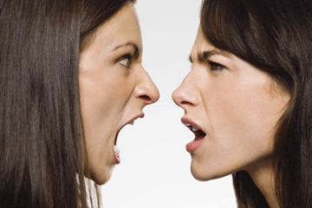As human beings, our only real method of connection is through **authentic** communication. Studies show that only 7% of communication is based on the written or verbal word, the remainder is via nonverbal body language. Indeed, it’s only when we can hear a tone of voice or look into someone’s eyes that we’re able to know when “I’m fine” doesn’t mean they’re fine at all…or when “I’m in” doesn’t mean they’re bought in at all.

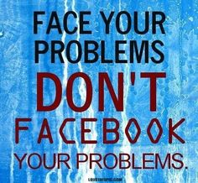This is where social media gets **dicey**.

**Awash** in technology, anyone can hide behind the text, the e-mail, the Facebook post or the tweet, projecting any image they want and creating an illusion of their choosing. They can be whoever they want to be. And without the ability to receive nonverbal **cues**, their audiences are none the wiser.

This presents an unprecedented **paradox**. With all the powerful social technologies at our fingertips, we are more connected – and potentially more disconnected – than ever before.

Every relevant **metric** shows that we are interacting at **breakneck** speed and frequency through social media. But are we really communicating? With 93% of our communication context **stripped away**, we are now attempting to **forge** relationships and make decisions based on phrases, abbreviations, snippets and emoticons, which may or may not be accurate representations of the truth.

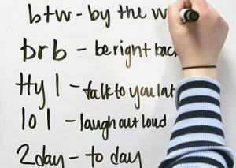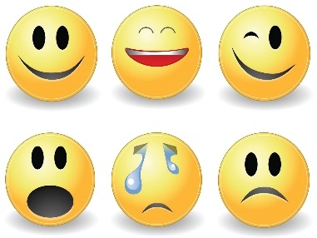

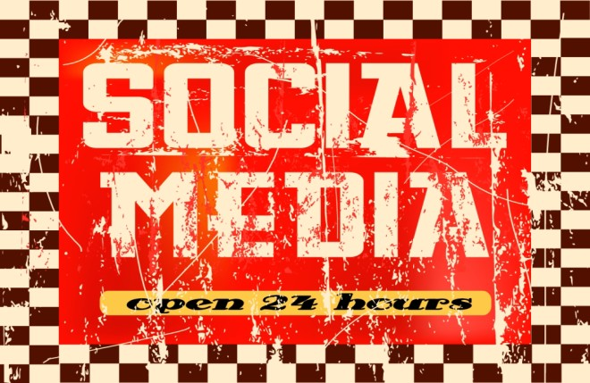Social technologies have broken the barriers of space and time, enabling us to interact 24/7 with more people than ever before. But like any revolutionary concept, it has **spawned** a set of new barriers and threats. Is the focus now on communication quantity versus quality, superficiality versus authenticity?

In an ironic twist, social media has the potential to make us less social; a **surrogate** for the real thing. For it to be a truly effective communication vehicle, all parties bear a responsibility to be genuine, accurate, and not allow it to replace human contact altogether.